R-1164
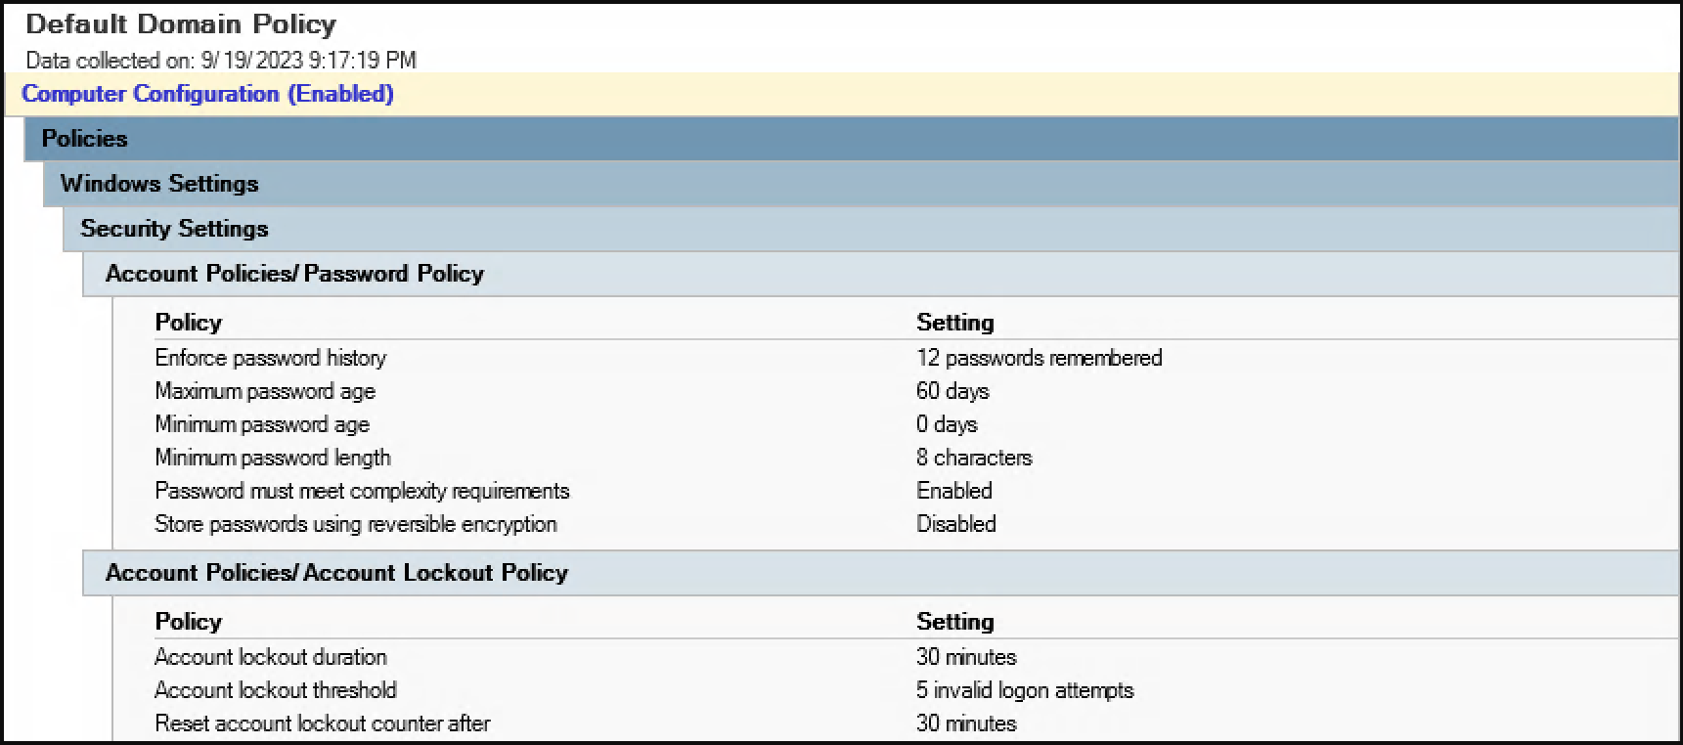
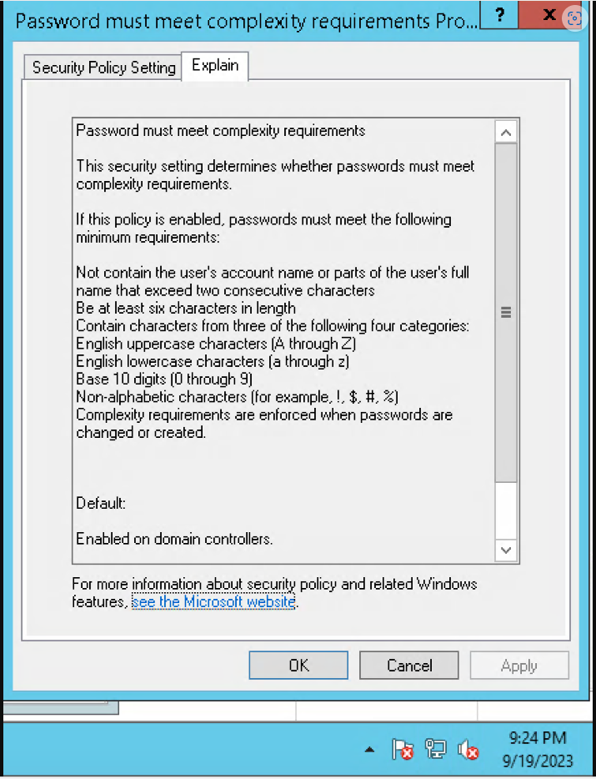

Include an export of the dc4pord log policy
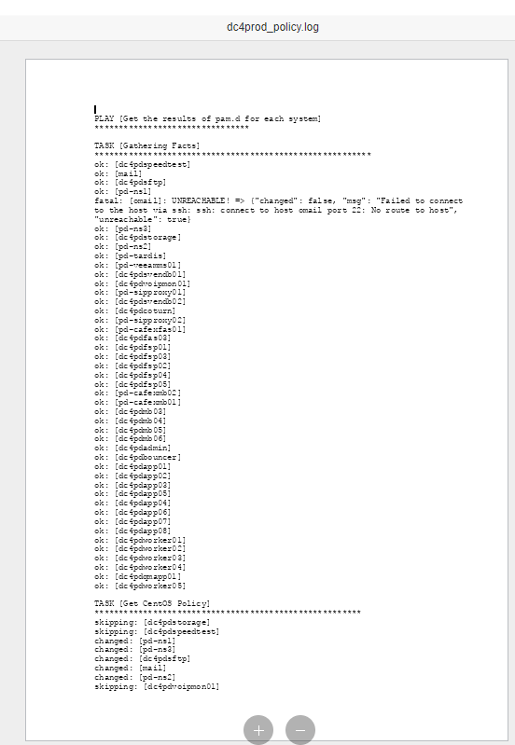

Include an export of the da6prod log policy
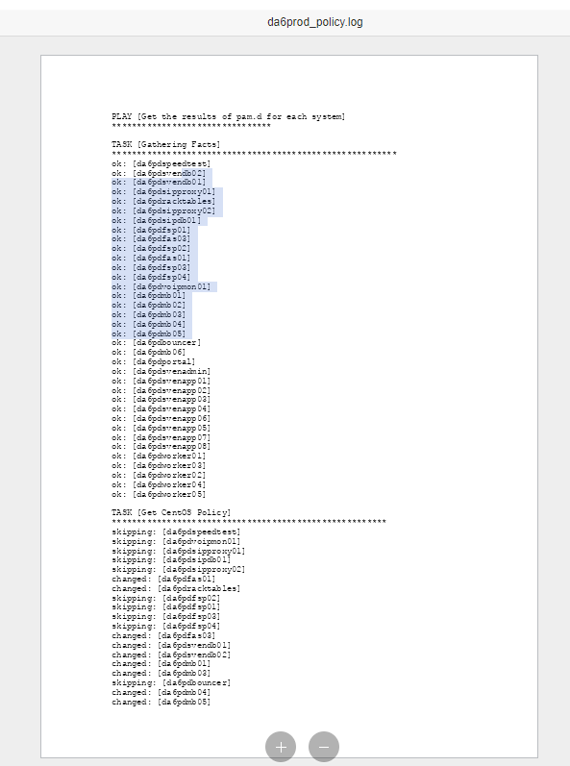

Include an export of the login.defs like you see below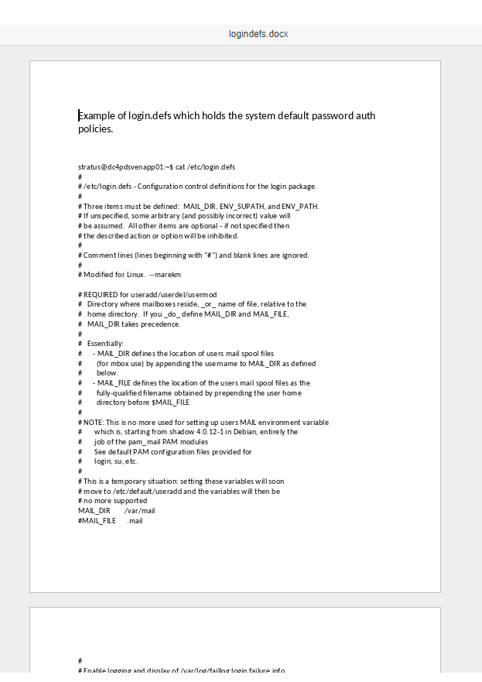
R-1165
Attach the dc4prod and da6prod logs policies and the logindefs that you also attached to R-1164

R-1166
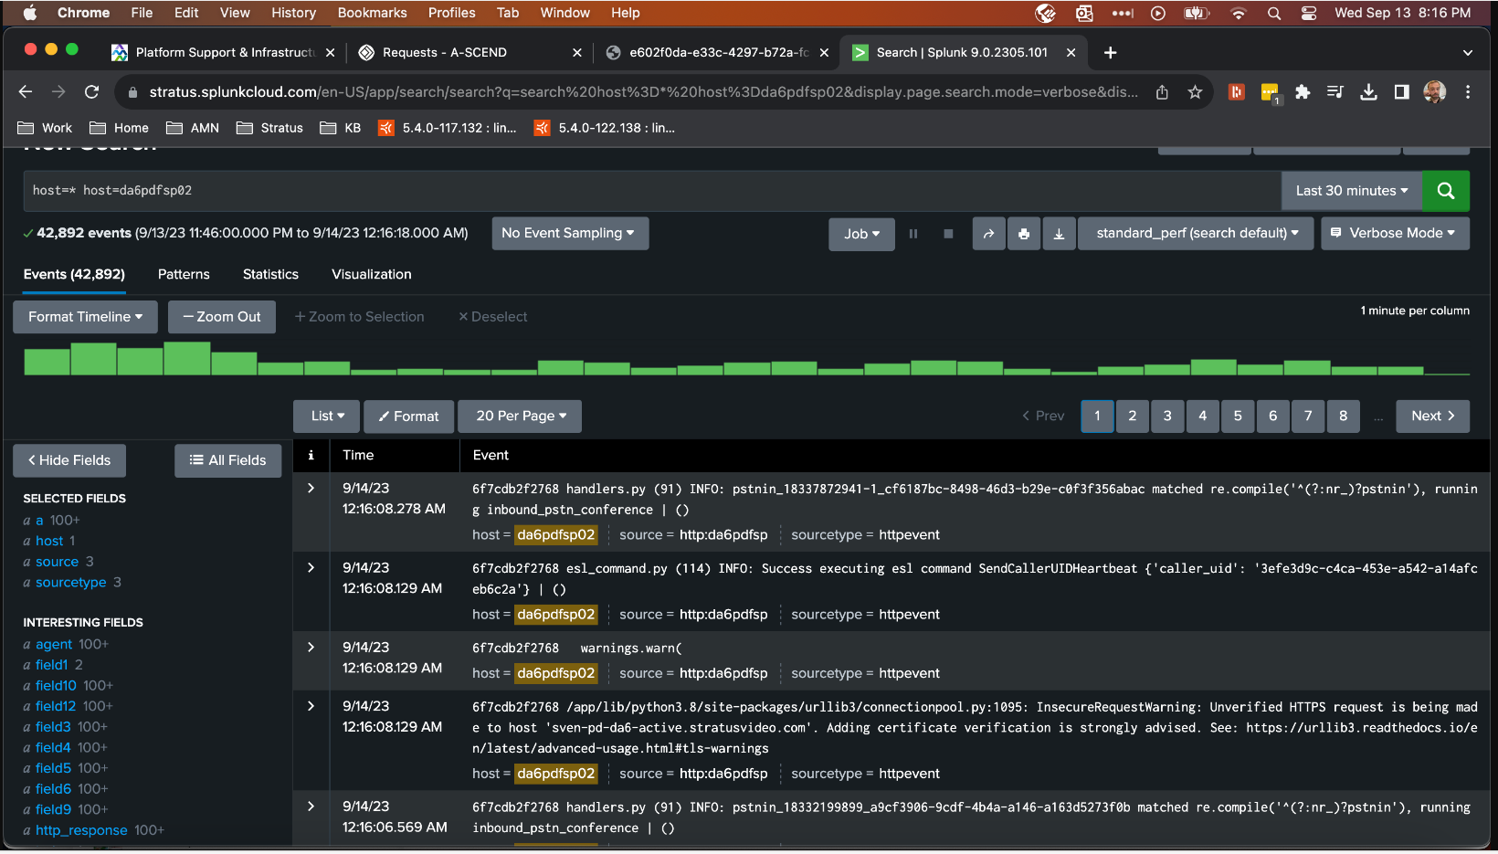
Generate and attach the csv for splunkforwarders like seen below
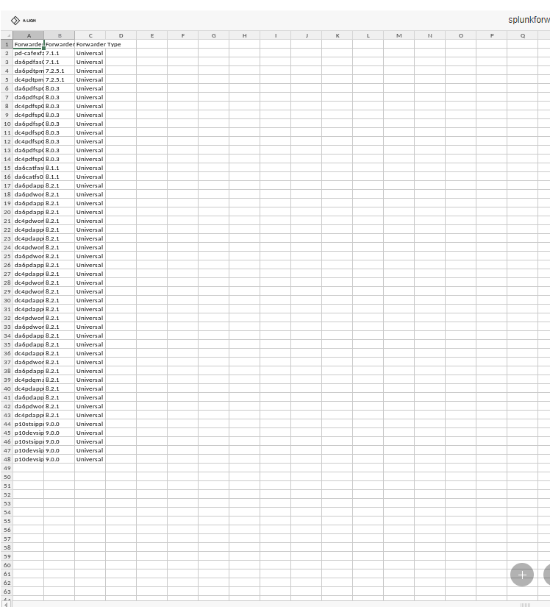
Generate and attach an example for da6pdfsp02_log_export like seen below. I know this may need to be a small example so that the file is not too large.
